An introduction to Global Value Chains

Economic theories and statistic tools take some time to adapt to new realities. It is also the case for international trade, where researchers and academia only recently started to build upon the new reality brought by globalization: from “made in one country” to “made in the world”, from “trade in goods” to “trade in tasks”, and from “value of trade” to “trade in value added” (TiVA).
The significant reduction in transaction costs associated with globalization, which allowed for a fragmentation of the stages of production, occurred in two waves. The first one was observed in the turn of the 19th to the 20th century, caused by the broad implementation of the steam machine in transportation. The second was witnessed in the second half of the 20th century, and particularly in the 1990s, caused by the wide use of Information and Communication Technologies (ICT). This second wave, allowing for the fragmentation of production in several stages, had particular impact in international trade, with cross-border trade in intermediate goods becoming dominant in world merchandise trade. This new reality represents a challenge for traditional trade policies and statistics, which failed to properly reflect the current complexity of international trade so far. We will focus on one of the new phenomenon that recently emerged due to globalization, namely the so-called Global Value Chains (GVCs), defined as worldwide production processes where fragmented production blocks are connected by service links.

What origin?

There seems to be a consensus between scholars that globalization started with the European age of discoveries and voyages to the New World and intensified at a rapid rate in the 20th century, especially during the Post-Cold War era. The term globalization has been in increasing use since the mid-1980s and especially since the mid-1990s.
Although critical for several areas of knowledge, understanding globalization is not an easy task. Baldwin (2011) provides with an important contribution to understand this phenomenon. This author states that, in the pre-globalized world, transactions were limited by three major factors: (i) transport; (ii) communication; and (iii) face-to-face constrain. Production was dispersed nationally, bundled to consumption, and no major international flows were observed. According to this author, a first unbundling of international trade occurred due to the wide use of the steam machine in transportation by the end of the 19th century. Figure 1 below shows how the introduction of the steam machine caused a rapid and significant decrease in transportation costs: the global trade cost measure used by the author decreased from above 1.8 in 1870 to slightly above 1.2 in 1912 (see left axis of the left-handed graph). In turn, the decrease in trade costs allowed for the international dispersion of products: the global trade flows measure used by the author increased from nearly 11 in 1870 to slightly above 12.5 in 1912 (see right axis of the left-handed graph). A second unbundling of international trade occurred in the second half of the 20th century. During this period, the average global trade cost measure decreased from nearly 1.4 in 1950 to slightly above 1.2 in 1974, while the measure of global trade flows increased from slightly below 12.5 to around 14.2 in the same period. In addition, an ICT revolution was observed from the 1980s onwards, with significant increases in the number of phone subscribers and of internet users, from around 900 thousand and 100 thousand in 1995 to more than 5 billion and 1.4 billion in 2007, respectively (see the right-handed graph in Figure 1). Baldwin (2011) notes in this regard that (i) world trade increased from representing 20% of global income in 1960 to nearly 50% in 2008, and that (ii) world trade grew 65% more than world output from 1990 to 2008. Note that, although the increase in global trade flows from 1870 to 1912 matched a manifest decrease in transportation costs, the increase in global trade flows observed from 1980 to 1985 occurred in a context of increasing trade costs. This is explained by the increase in the use of ICT.
Figure 1 - Long-term trade costs versus global trade flows (1870-2000, left) and ICT indicators (1975-2011, right)
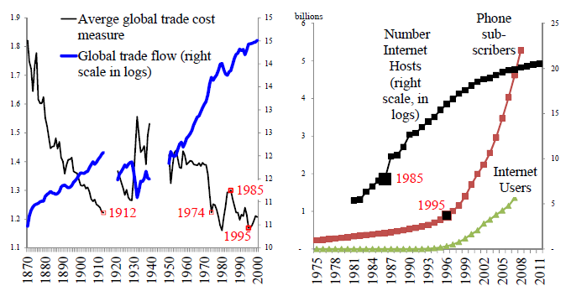
Source: Baldwin (2011, p. 11).

This increase in the use of ICT was described by Baldwin (2011) as a second revolutionary transformation, due to their impact in the reduction of both transaction and communication costs. It allowed for the regional dispersion of production stages, the so-called internationalization of supply chains, international fragmentation of production or, yet, GVCs. Until that moment, industrialization was based on domestic supply chains. After this second unbundling, industrialisers started taking advantage of offshored production to incorporate elements that would take decades to develop domestically. The offshoring typically started with a decision by a large high-tech multinational firm from a developed country to rely on the provision of intermediate goods and services by several other small and medium firms located in low-wage and low-skilled developing countries. This high-tech multinational firm offshored codifiable tasks with low value-added, such as manufacturing and assembling, while strategically keeping some stages of production in-house, usually non-codifiable tasks with high value-added, such as standardization, innovation, Research and Development (R&D), marketing, branding, and costumer services.
Degain (2012) showed that value-added is higher on the early and on the late steps of the manufacturing process (see Figure 2 below), namely in standardization, innovation, and R&D (early) and in marketing, branding, and customer services (late).
Figure 2 - Added value of typical stages of production in manufacturing
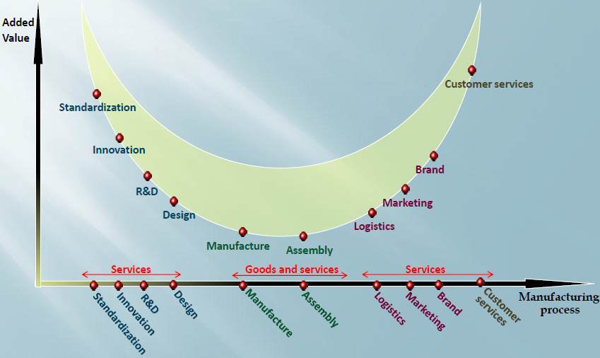
Source: Degain (2012).

Several authors showed that the participation in fragmented value chains is an efficient way for a firm to improve its production process and have access to new technology (see Coe & Helpman, 1995; Keller, 2002; and Lemoine & Ünal-Kesenci, 2004, as examples), while being absent from those chains decreases its growth (see Yi, 2003; and Baldone et al, 2007). For those sectors where production is already fragmented, the future of a producer outside the value chain is not promising, unless that firm controls a very exclusive and advanced technology. From a macro perspective, the importance of GVCs for the world’s economic growth was highlighted by the World Economic Forum (2013), which concluded that concerted action to reduce supply chain trade barriers could increase global Gross Domestic Product (GDP) up to six times more (by 4.7%) than removing all remaining import tariffs (0.7%).
Finally, Baldwin (2011) forecasted a third unbundling that will occur at some point in the future, when the face-to-face constrain ceases to exist. In such a scenario, production stages are projected to disperse globally and other regions, such as Africa and South America, would join supply chains.
In fact, one could conclude that GVC is a misleading designation. First, as noted by Baldwin (2011), they are not global, but located in one or in several of the following three regions: Central Europe, North America and, mainly, East and Southeast Asia, with no substantial connections between them. Second, as noted by OECD et al (2014), they are not chains, but ladders, since «the disaggregation of production into separate stages allows their firms not only to find their place on the ladder, but to move up the rungs as their capabilities improve». Therefore, a reference to “regional value ladders” could be more adequate than GVCs. We will confirm this approach particularly in Chapter 2 of this thesis.
The second unbundling, as described by Baldwin (2011), led to four major changes in international trade: (i) cross-border trade in intermediate goods dominates now world merchandise trade; (ii) geography of manufacturing evolved; (iii) the impact of traditional trade policies decreased, as they do not take into account the international fragmentation of production, so other instruments of trade policy emerged; and
(iv) traditional trade statistics and measures became outdated. We will look into each one of these four changes in more detail next.
First, cross-border trade in intermediate goods increased significantly. Most of the recent increase in global trade was due to the sizeable growth of trade in parts and components. Mirodout et al (2009) showed that international trade in intermediates accounted for about 60% of the USD 20 trillion annual global trade in 2005 (56% in the case of goods and 73% in the case of services). Figure 3 below shows that the VS index, taken as a proxy for supply-chain trade, increased mainly in Asia, from 1990 onwards. This index, estimated by Baldwin & Lopez-Gonzalez (2015) according to the methodology presented by Amador & Cabral (2009), is based on the intuition that if a country simultaneously exports a product and imports a related intermediate good in such a way that their relative shares are much higher than the average of the other countries, then international vertical linkages must play a role.
Figure 3 –The observed increase in vertical specialization in Asia
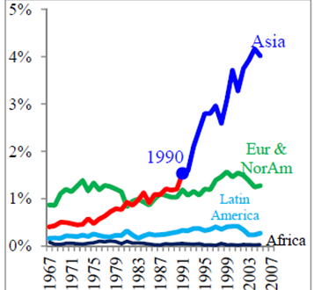
Source: Amador & Cabral (2009)'s proxy for supply-chain trade, as presented by Baldwin & Lopez-Gonzalez (2015). Eur & NorAm stands for Europe & North America.

Second, geography of manufacturing changed. A major transformation was observed in the relative weigh of manufacturing economies. Figure 4 below shows that, although the United States (US), Germany and Japan jointly accounted for nearly 53% of the world's manufacturing production in 1970, their share decreased to 37% in 2010. Following this trend, the relative weigh of the economies of the Group of the seven major advanced nations (G7) dropped from 65% to 47% of global manufacturing share (18 percentage points, pp) from 1990 to 2010. On the opposite direction, the weight of the People’s Republic of China (PRC) increased by 16 percentage points in the same period, while six other nations also saw their shares rise by more than half percentage point, namely: India, Indonesia, Poland, South Korea, Thailand, and Turkey.

Figure 4 – Change in the relative weight of manufacturing economies between 1970 and 2010
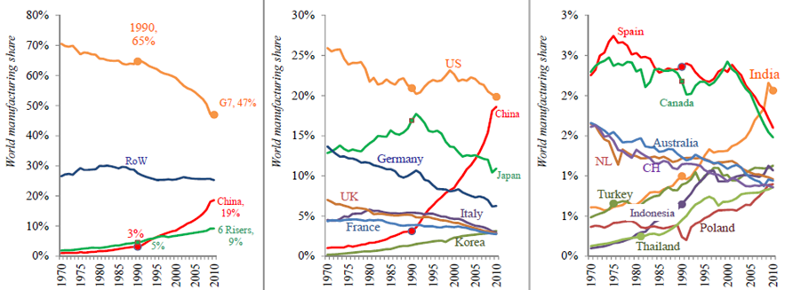
Source: Baldwin & Lopez-Gonzalez (2015), based on data from unstats.un.org. Three graphs are depicted due to the change in scale on the y-axis. G7 countries are: Canada, France, Germany, Italy, Japan, the United Kingdom (UK), and the US. Other developed countries are also depicted in the right-handed graph, for comparison, namely: Australia, the Netherlands (NL), Spain, and Switzerland (CH). The shares of these countries also decreased.

This major change in the location of manufacturing had a strong focus on Asia. Figure 5 below shows in red those countries where the annual growth in manufacturing-GDP was at least 5 to 10 percentage points higher than the world’s average between 1995 and 2007. Almost all of them were Asian countries. Particularly, East Asia was the only region in the world where, in addition to the co-existence of structural macroeconomic and microeconomic factors that promoted its productive integration, public institutions actively reinforced the necessary conditions for the promotion of the international fragmentation of production (see Medeiros, 2010). The Asian Development Bank (ADB) designated this region as “Factory Asia”. Empirical data supported this statement: e.g. first, the foreign content in exports of electronic goods in the PRC and in South Korea, the world’s largest exporters in this sector, was nearly 40% in 2009, according to OECD & WTO (2013); second, the weight of imported parts and components in total PRC exports of manufactured goods represented nearly 70% in 2005 (Mirodout et al, 2009). For comparative purposes, we present now (in footnotes) lists of the main empirical studies carried out in other regions of the world, namely in the OECD countries, North America, Mercosur and the European Union (EU).
Figure 5 - Geographic clustering of growth in manufactures (annual manufacturing-GDP growth compared to the world's average, from 1995 to 2007)
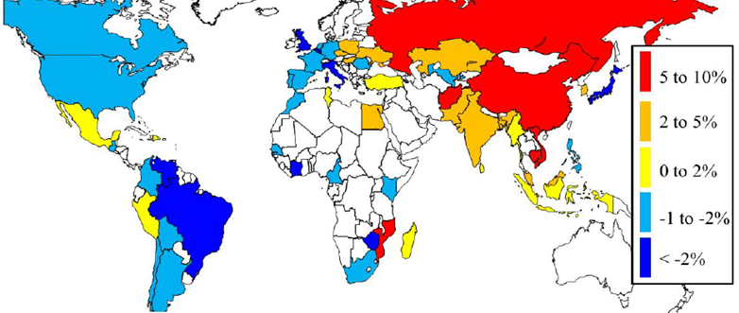
Source: Baldwin & Lopez-Gonzalez (2015). The assessment only covers economies with more than 10 million inhabitants and minimally industrialized (share of manufacturing-GDP at least as big as Kenya’s).

Third, trade policies became less relevant and started changing. Many developing economies that had resisted to trade and investment liberalization until the end of the 1980s started to implement measures to integrate themselves into international production sharing. First, tariffs were reduced unilaterally in all regions, and particularly in Asia, as shown in the left-handed graph in Figure 6 below. Second, pro-supply chain agreements blossomed, particularly unilateral concessions to attract investment from developed nations and Bilateral Investment Treaties (BITs), as shown in the centered graph in Figure 6. Third, annual flows of FDI increased from around USD 200 billion in 1988 to more than USD 2 trillion in 2007 (see also centered graph). Fourth, the number of deep provisions in new Regional Trade Agreements (RTA) (such as competition policy, capital movements and assurances for intellectual property, which are pro-supply-chain) increased significantly in the first decade of the century (see right-handed graph in Figure 6). As stated by Flôres (2010), «in a moment where trade negotiations have become so tight, (…) deeper knowledge of how each economy is placed within the fragmentation context seems mandatory».
Figure 6 - Applied trade tariffs (left), new BITs signed and annual FDI flows (center), and number of deep provisions in new RTAs (right)
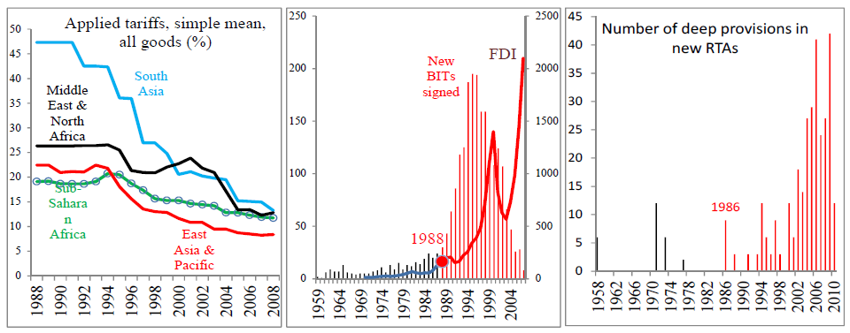
Source: Baldwin & Lopez-Gonzalez (2015).
Fourth, awareness grew that traditional trade statistics may give a misleading perspective of trade flows and that «what you see is not what you get» (Maurer & Degain, 2010). UNCTAD (2013c) concluded that traditional statistics overstate the volume of total trade flows. These authors noted that 28% of the value of world cross-border trade in goods and services in 2010 (about USD 5 trillion) was magnified as a result of double counting. The rationale is that the value of exported goods includes the value of the imported inputs used in their production, which were internationally traded already, so the value of those inputs, for purposes of international trade record, will be counted twice: first, individually, when imported as parts and components, and, second, when the final good is exported, embedded in its exported value. Following OECD & WTO (2013), let’s admit a world with three countries: A, B and C. Country A exports USD 100 of goods produced fully domestically to country B. Then country B further processes them into more complex goods before exporting them to country C for USD 110, where they are consumed. In this sequence, country B adds value worth USD 10 to the initial goods. Conventional measures of trade would show global trade flows totaling USD 210. However, total value-added was only USD 110 (USD 100 by country A and USD 10 by country B). Moreover, conventional measures would also show that country C has a trade deficit of USD 110 with country B, and no trade at all with country A. However, we note that country A is the major beneficiary of country C’s consumption. By making use of value-added statistics, we would observe that country C’s net deficit with country B is not USD 110. Country C's net deficit is USD 10 with country B and USD 100 with country A.
Two well-discussed studies of the implications of value-added statistics in real trade flows were provided (i) by the Swedish National Board of Trade (National Board of Trade, 2007), regarding the European shoe industry, and (ii) by Xing & Detert (2010), regarding Apple’s iPhone. First, the National Board of Trade (2007) concluded that shoes “Made in Asia” incorporated between 50% and 80% of EU value-added in 2005. If EU policy makers had had that information available in due time, it is likely that they would have re-assessed the introduction of anti-dumping tariffs on shoes imported from the PRC and Viet Nam that they approved in 2006. Second, Xing & Detert (2010) tracked the manufacturing process of the iPhone. They observed that, according to traditional trade statistics, the production of the device was contributing significantly to the US bilateral trade deficit with the PRC (with nearly USD 1.9 billion in 2009). PRC exports got the full credit of the iPhone's value to the US. However, these authors noted that, in value-added terms, the PRC was only responsible for the assembly in its factory in Shenzhen of the several parts and components of the iPhone imported from several other locations around the world, namely from South Korea, Japan and Taiwan, as well as from the US itself. They also noted that PRC workers were adding very little to the value of the iPhone in the manufacturing process – a mere 3.6% of the final cost. Finally, they estimated the iPhone-related bilateral trade balance between the US and the PRC, based on the actual value-added flows, and concluded that, because a significant portion of the parts and components assembled into the iPhone in Shenzhen were imported from the US, the iPhone-related US bilateral trade deficit with the PRC in 2009 would not have been USD 1.9 billion, as traditional trade statistics showed, but USD 73.5 million (close to balance).
The rationale of why traditional statistics fail to give a truthful picture of today’s trade is sound: they fail to measure the value-added of international trade, as well as its appropriation. Even the work carried out by Xing & Detert (2010) does not tell the whole story. In tracking the manufacturing process of the iPhone, these authors only considered its direct (first-round) intermediate inputs. However, those direct intermediate inputs, imported from a given country (South Korea, the US, Taiwan, and Germany, mainly), were certainly manufactured with inputs produced in a third country: the so-called second-round inputs (which could also include third-, fourth- or fifth-round inputs). Information on all the suppliers' suppliers would be needed (and so on and so forth). Just to have a glimpse about the importance of these flows, OECD & WTO (2013) concluded that in the US, for example, nearly 5% of the total value of imported inputs reflected US value-added. In the PRC, the analogous figure was close to 7%. Specifically for electronic goods, PRC intermediate imports contained over 12% of “returned” PRC domestic value-added. South Korean intermediate imports also contained close to 5% of “returned” South Korean domestic value-added. Identifying these second-round inputs is critical to be able to make the right attribution of value added.

How should we measure it?

Indicators are not only critically influenced by the scope of the concept definition used, but also by the data they rely upon. In section 1.3, we will present the main sources of data used to measure the impact in international trade of the international fragmentation of production, namely: (i) statistics of international trade in parts and components; (ii) customs statistics of international trade for processing goods; (iii) firm-level data; and (iv) national accounts and, more recently, internationally linked Input-Output (IO) databases. The main characteristics, pros and cons of each one of these four approaches are summarized in detail in Table II below, paying particular attention to their data availability and comparability, geographic coverage, level disaggregation, and sectoral coverage.
Table II – comparison of the several approaches found in literature to empirically estimate the impact in international trade of the international fragmentation of production
 | Data availability and international comparability | Geographic coverage | Level of disaggregation | Sectoral coverage
Statistics of international trade in parts and components | Very good | Very good | Good | Low
Customs statistics of international trade for processing goods | Low | Low | Very good | Low
Firm-level data | Low | Low | Very good | Low
National accounts and internationally-linked IO databases | Very good | Good | Good | Very good
Source: Author.

The first type of data used by authors to empirically estimate the impact in international trade of the international fragmentation of production was based on the conventional international trade statistics. They were used to assess the relative weight of goods classified as parts and components in total trade flows, due to their large coverage and availability of data, both in terms of time and space, and therefore endowed with easy international comparability,. However, the drawbacks observed in these data are that (i) the reliability of its results depends on the level of disaggregation of the statistics, which should ideally be based on an adequate distinction between intermediate and final goods; (ii) they are based on an (arbitrary) assessment of which goods and products can be considered intermediate or final, as mentioned by De Backer & Yamano (2007); and (iii) the early works do not cover services. The emergence of GVCs makes this distinction even less clear, as close-to-final products are often further processed in subsequent production and distribution stages within companies. In addition, these data do not differentiate between assembling activities; imports of final goods used in domestic production; re-imports of final goods that were previously exported by local firms; imports of goods that could have been alternatively produced and consumed domestically; and imports of goods that could have been alternatively produced domestically and then re-exported to third markets.
The second type of data used by authors to empirically estimate the impact in international trade of the international fragmentation of production was based on the customs statistics of international trade for processing goods,. These data were collected under a country’s customs legal framework for purposes of granting tax exemption or reduction depending on the domestic input content of re-imported goods. It therefore follows very closely the geographical origin of the inputs included. Its drawbacks are that (i) coverage is narrow (data do not cover goods processed overseas nor direct exports to third markets); (ii) data do not differentiate between intra-firm and inter-firm flows; and (iii) international comparability and time consistency of data are low or none.
The third type of data used by authors to empirically estimate the impact in international trade of the international fragmentation of production was based on firm-level detailed data about transactions of a given transnational firm in the countries where that firm operates,. They are extremely detailed data, often collected through surveys, so they provide unique information about outsourcing and offshoring. Although limited to a given firm, they are consistent and allow for international comparability. Their drawbacks are that (i) firms are often reluctant to give information about their operations, especially about relocation decisions; and (ii) geographical and sectoral coverage are very limited, related only to the operations of the firm.
The fourth type of data used by authors to empirically estimate the impact in international trade of the international fragmentation of production was based on national accounts and, more recently, on national IO matrices linked via international trade data. IO matrices classify goods per sectors according to their use (input or final demand) and not to their theoretical classification. Coverage is wide, including services. Consistency and international comparability are good. In addition, IO matrices easily allow for sectoral analysis. They also provide disaggregated information about offshoring and about the provision of both domestic and foreign intermediates. The drawbacks are that (i) internationally-linked IO databases are only available in a consistent manner and for a significant number of countries and sectors since 2013 (although they include data that go back to the 90s); and (ii) IO matrices do not show second-round effects, i.e. they do not include data related to the inputs of the inputs.
We observe that the three first approaches present significant shortcomings and partiality in the information they provide to assess the international fragmentation of production. Most drawbacks are nevertheless overcome by internationally-linked IO databases, such as the WIOD and the Made-in-the-World Initiative (MIWI). These matrices represent a critical innovation towards properly measuring the international fragmentation of production, as they group goods and services in inputs and final demand according to the use they had in the economy (unlike the statistics of international trade, which rely on the standard and descriptive classification given to any product, regardless of the way that the product was actually used, even for highly disaggregated levels of information). This difference is crucial, since virtually all products and services are used in practical terms both as inputs and as final consumption.
The basic structure of an IO table, conceived as a supply and use table of national production, can be seen in Figure 8 below. It provides data on the interactions between suppliers (rows) and users (columns) of (i) domestically produced and consumed intermediates (raw materials, industrial parts and components and services); (ii) domestically produced and consumed final goods, in private final consumption, in Government final consumption or in Gross Fixed Capital Formation (GFCF);
(iii) domestically produced and exported final goods; and (iv) externally produced imported intermediates.
Figure 8 - The basic structure of an IO Table
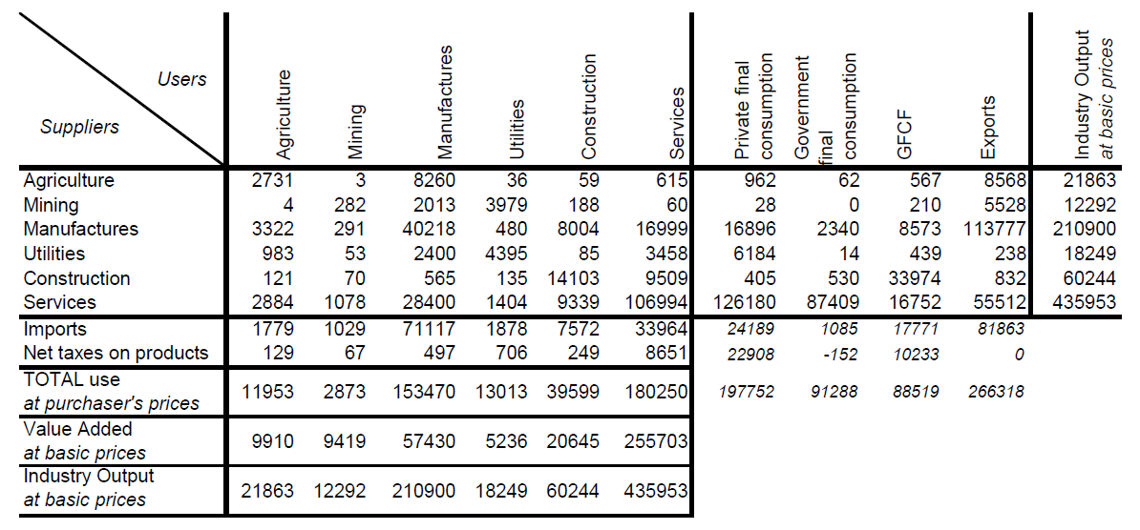
Source: Wixted et al (2006).

It must be underlined that this matrix is a supply and use table of national production, as referred in Eurostat (2008), and not a supply and use table of total flows in the economy, since information is not presented about imports of final goods, including those re-exported with no value-added in the domestic economy. A supply and use table of total flows would also present an additional row for imports of final goods. This missing information is not relevant, nonetheless, for the purpose of this thesis, i.e. assessing the participation of domestic production in GVCs.
On one hand, rows give information about how the production of a given sector was used (user’s or upstream approach), namely as (i) inputs in the production processes of other sectors; (ii) inputs the production process in the same sector;
(iii) domestic final private consumption; (iv) domestic government final consumption; (v) domestic GFCF; and (vi) exports abroad. If we take the case of the uses of the production of the agriculture sector in Figure 8 above (row 1), we observe that
(i) 2,731 units were used as inputs in the agriculture sector itself; (ii) 3 units as inputs in the mining sector; (iii) 8,260 units as inputs in the manufactures sector; (iv) 36 units as inputs in the utilities sector; (v) 59 units as inputs in the construction sector;
(vi) 615 units as inputs in the services sector; (vii) 962 units as domestic final private consumption; (viii) 62 units as government final consumption in the country;
(ix) 567 units as domestic GFCF; and (x) 8,568 were exported (both as inputs and as final consumption).
On the other hand, columns give information about how the output of a given sector was produced (supplier’s or downstream approach), namely with supplies from (i) domestic inputs from other sectors of activity; (ii) domestic inputs from the same sector; (iii) imported inputs; (iv) net taxes levied on products; and (v) value-added in the sector, at basic prices, representing the sum of wages and salaries (remuneration of labor) and gross operating surplus (remuneration of capital). If we take the case of the supplies for the production of the agriculture sector in Figure 8 above (column 1), we observe that the value of the sector’s output splits into (i) 2,731 units of inputs from agriculture itself; (ii) 4 units of inputs from mining; (iii) 3,322 units from manufactures; (iv) 983 units from utilities; (v) 121 units from construction; (vi) 2,884 units from services; (vii) 1,779 units of imported inputs; (viii) 129 units of taxes on products; and (ix) 9,910 units of value-added in the sector, at basic prices.
In Figure 8 above, we highlighted in red the intermediate goods matrix, which provides data about the interactions between domestic suppliers and domestic users of domestically produced goods and services. It is by definition a squared matrix and the values recorded can be either at basic or at purchaser’s prices. We also emphasized in green the row vector representing the economy’s total imported inputs, per sector. Finally, we highlighted in blue the matrix representing the uses of the goods and services produced in the economy excluding its use as inputs in domestic industries.
Figure 9 below shows the international linkage between the IO tables of several countries. It basically disaggregates the column called “Exports” of Figure 8 above into several submatrices that present, for the trading partner economies, information about how the exported domestic goods and services have been used, by country of destination and by use (as inputs, per sector; as private final consumption; as government final consumption; or as GFCF). Taking again the example of agriculture, we mentioned before in Figure 8 that that sector supplied foreign users with 8,568 units. In addition, Figure 9 shows that those 8,568 units, disaggregated per country and per final use, were used, for example, as it follows: (i) 343 units as inputs in the production of manufactures of country B; or (ii) 1,285 units as private final consumption also in country B. The same rationale applies in terms of columns, where Figure 9 below basically disaggregates the row called “Imports” of Figure 8 above into several submatrices that present, for the trading partner economies, information about how the imported foreign goods and services have been used as inputs in country A’s economy, by country of origin and by sector. We observe in this regard that the value of the 1,779 units of foreign imports used as inputs mentioned in Figure 8 included, for instance:
(i) 338 units of inputs from the services sector of country B; or (ii) 107 units of inputs from the construction sector in the Rest of the World (RoW), i.e. in countries not specifically covered in the sample.
Figure 9 - The basic structure of an internationally-linked IO table (for three regions)
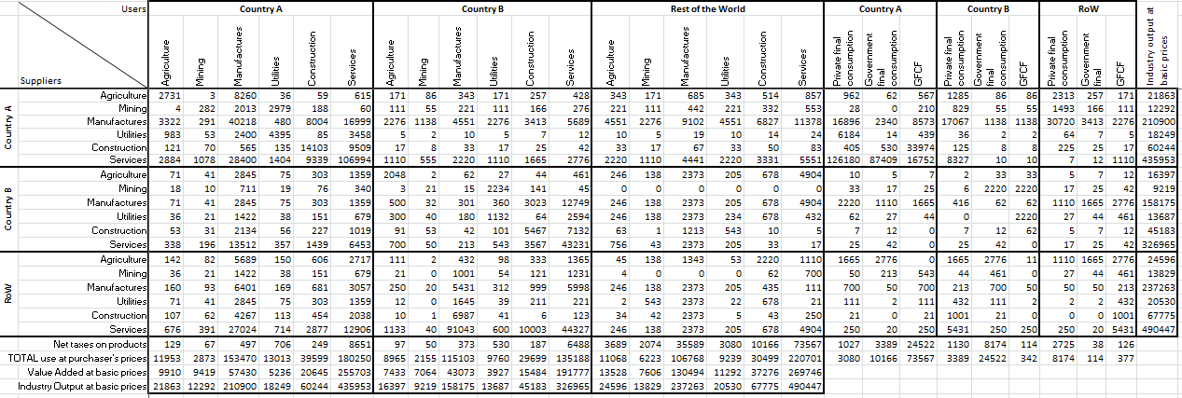
Source: Author, based on Timmer et al (2012a).
Several initiatives emerged in recent years to work with IO matrices: initially with national accounts and, more recently, with internationally-linked IO matrices linking production via trade in inputs within and across countries and sectors. Table III below specifically compares the scope and reach of the main internationally-linked IO databases created so far, namely: (i) the Global Trade Analysis Project (GTAP) database, launched by Purdue University, its first version dating back to 1993, but with a very limited scope; (ii) the Institute of Developing Economies of the Japan External Trade Organization (IDE-JETRO) database, the most recent version launched for 2005; (iii) Eurostat IO databases, existing for selected EU countries; (iv) the WIOD, launched firstly on April 2012 by the University of Groningen; (v) the MIWI, launched on January 2013 jointly by the OECD and the World Trade Organization (WTO); and (vi) the EORA-GVC database, launched in February 2013 by the UNCTAD, focused on the nexus between trade and investment, although currently still in the format of meta database. Particularly the WIOD and the MIWI became widely-used tools to assess the effects of the international fragmentation of production. Enthusiastic trade economists rapidly started using them, for example, to slice up GVCs and derive new measures of competitiveness and TiVA or to measure the effects of international outsourcing in labor demand or in inequality.

Table III - Comparative analysis of the main internationally linked IO databases
Project | Institution | Data sources | Countries | Industries | Years | Comments
MIWI | OECD-WTO | National IO tables | 56 | 18 | 1995, 2000, 2005, 2008, and 2009 | Based on national IO tables, harmonized by the OECD.
WIOD | Consortium of 11 institutions led by Groningen University, EU funded | National Supply-Use tables | 40 | 35 | 1995 to 2011 | Based on official national accounts statistics, it uses end-use classification to allocate flows across partner countries. It also includes data on socioeconomic and environmental issues.
UNCTAD-EORA-GVC database | UNCTAD-EORA | National supply-use and IO tables, and IO tables from Eurostat, IDE-JETRO and OECD | 187 | 25-500, depending on the country | 1990 to 2011 | Meta database consolidating several different sources and interpolating missing points to provide broad, consistent coverage, even of data-poor countries. It includes (i) data on environmental indicators; and (ii) estimates of standard deviation for all results. It differentiates between basic prices and purchasers' prices.
Asian International IO tables | IDE-JETRO | National accounts and firm surveys | 10 | 76 | 1975, 1980, 1985, 1990, 1995, 2000, 2005 | US and Asia tables plus bilateral tables, including PRC-Japan.
GTAP | Purdue University | Contributions from individual researchers and organizations | 190 | 57 | 2004, 2007 | Unofficial dataset; includes data on areas such as energy volumes, land use, carbon dioxide emissions and international migration.
Source: UNCTAD (2013b), p. 124.

While the MIWI, with a more narrow coverage in time and sectors, aimed at supporting the exchange of projects and experiences in measuring and assessing TiVA, the WIOD offered new and unique opportunities to study the effects of the international fragmentation of production on a wide range of socioeconomic and environmental issues. In fact, this database, which was based on a set of harmonized supply-and-use tables linked with data on international trade in goods and services, was complemented with environmental and socio-economic indicators, such as industry-level data of capital stock, investment, wages and employment (by skill-type).
One should bear in mind that internationally-linked IO matrices are an estimate, based on a number of assumptions, rather than a measurement, as mentioned by Escaith & Timmer (2012). First, any large discrepancy between values recorded in IO national accounts and in international trade statistics or between importer and exporter's reporting needs to be reconciled. Second, IO domestic tables are not estimated on an annual basis. They are compiled every five years, at best, due to the significant compilation effort that they involve. Consequently, annual data presented in annual IO are a mere interpolation estimated by the authors. Third, firm surveys are needed to split the IO tables between export-oriented and domestic-oriented firms.
Having said that, the main empirical studies making use of internationally-linked IO databases could be divided into four groups according to their object of study:
(i) making use of international trade and national accounts to assess the foreign content of the domestic production, particularly used in the analysis of the impact of the international fragmentation of production in labor markets; (ii) making use of international trade and national accounts to assess the foreign content of the domestic exports; (iii) linking ad hoc bilateral trade databases and IO matrices; and
(iv) making use of the WIOD or of the MIWI databases.
Some interesting empirical findings related to GVCs were found so far by assessing internationally linked IO databases. We will present next a few, as a proof of the empirical wealth that these data provide for research.
First, value-added trade is relatively more advantageous for developing than for developed countries. UNCTAD (2013c) makes use of internationally-linked IO databases to conclude that: (i) value-added trade contributed on average nearly 28% to the GDP of developing economies, as compared to 18% for developed economies; (ii) the relative share of developing countries in global value-added trade increased from 20% in 1990 to 42% in 2010; (iii) the participation of developing countries in GVCs was growing at 6.1% per year (9.6% for the least developed countries); and (iv) developing countries with the fastest growing participation in GVCs had GDP per capita growth rates more than two percentage points above the average.
Second, GVCs played a double but contradictory role in influencing the transmission mechanism of supply and demand shocks. On one hand, at micro-level, the shock is propagated up and down the GVC. This effect has been designated in the literature as “bullwhip effect”. When there is a sudden drop in demand, firms delay orders and run down inventories, amplifying the fall in demand along the GVC. On the other hand, at macro level, GVCs change the impact of currency fluctuations on trade. When our currency appreciates, our exports become more expensive, but there is also a corresponding decrease in the cost of imported inputs. A better understanding of TiVA flows would therefore provide tools for policymakers to anticipate the impact of macro-economic shocks and adopt the right policy responses.
Third, regarding the role played by services in international trade, statistics in TiVA presented significantly higher relative weight than traditional statistics. UNCTAD (2013c, p. 135) concluded that, while services typically represented around 20% of total gross trade, their share more than doubled to 46% when accounted for value added in exports. OECD & WTO (2013) reached a similar conclusion (see Figure 10 below).

Figure 10 - Relative weight of services in total gross and total value-added exports (for selected countries, 2009)
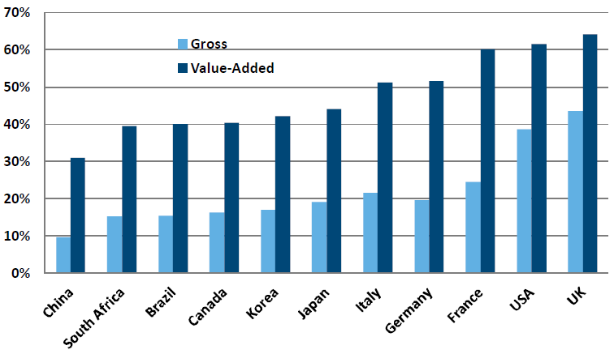
Source: OECD & WTO (2013).

Finally, regarding the new winners and losers of bilateral trade, the OECD, under the so-called joint OECD-WTO TiVA initiative, started in January 2013 to publish bilateral trade balances measured in TiVA terms on a regular basis. In its first release, the OECD estimated that the US trade deficit with the PRC in 2009, measured in TiVA terms, was 25% smaller than when measured in gross terms, largely because PRC businesses use inputs supplied by other countries, including the US, to make the goods that eventually sell to US consumers (as referred at the product level for the iPhone case in section 1.1 of this thesis). US bilateral trade deficits were also smaller with Canada and Mexico when measured in TiVA terms (they were larger with Japan and Germany though). Additionally, the US substituted France as both Germany's largest client and supplier when TiVA replaced gross data, indicating that what Germany bought from other European nations might have had a significant US component embedded.

The average global trade cost measure presented by Baldwin (2011) was estimated with a gravity regression. It was based on the micro-based measure of trade friction suggested by Jacks et al (2011).
For more detailed information about the role played by services supporting manufacturing, see Feenstra (1998), Amiti & Wei (2005, 2006), Van Long et al (2005), Cadarso-Vecina et al (2007), and Meng et al (2011). Van Long et al (2005) showed how the strongest linkages in Vertical Specialization (VS) were related to services (e.g. finance and insurance in Luxembourg, or transport and storage in Norway). Amiti & Wei (2005) described how fragmentation increased in business processing services and ICT industries in recent years.
OECD et al (2014) goes deeper into this issue by stating that «GVCs encourage that upward movement by rewarding skills, learning, and innovation. Overcoming obstacles to GVC-participation can pay big dividends; developing economies with the fastest growing GVC-participation have GDP per capita growth rates 2% above average. In fact, some developing countries have benefited not just from the foreign investments in the production of goods and services, but increasingly in more advanced operations such as research, design, and innovation».
Other empirical studies consistently produced similar results, notably: (i) Feenstra (1998) concluded for several indicators that the countries of the Organization for Economic Co-operation and Development (OECD) generally observed an increase in the use of imported inputs and a reduction in the use of domestic inputs between the 1970s and the 1990s; (ii) Yeats (2001) and Hummels et al (2001) concluded that VS was responsible for nearly 30% of global trade in manufactures in 1995; (iii) Yi (2003) concluded that at least half of the increase in international trade observed since the 1960s could be explained by VS; (iv) Jones et al (2005) and Athukorala & Yamashita (2006) showed that the growth rates observed in parts and components persistently outpaced the growth rates observed for final goods during recent decades; and (v) WTO (2009) concluded that manufactured intermediate goods represented around 40% of non-oil world trade in goods in 2007.
Consisting of Canada, France, Germany, Italy, Japan, the UK, and the US.
The following list presents some of the most significant studies carried out for this region: Akamatsu (1962), UNCTAD (1996, 2007), Kojima (2000), Chudnovsky & Fanelli (2001), Yeats (2001), Ng & Yeats (1999, 2003), Lemoine & Űnal-Kesenci (2004), Lall et al (2004), Tomiura (2005, 2007), Uchida & Inomata (2009), Yamano et al (2011) and Medeiros (2010) for Japan; Kimura & Ando (2005) and Ping (2005) for the US-PRC relations; Gaulier et al (2005, 2006), Kimura et al (2007), Zhang & Sun (2007), Brooks & Changchun (2008), Aminian et al (2007), Dean et al (2007), Koopman et al (2008), Dean et al (2008) and Yang et al (2009) for PRC; Ando (2006), Athukorala & Yamashita (2006) and Chen & Chang (2006) for Taiwan and South Korea; and Dean et al (2009) for the US-Japan-PRC relationship.
See Feenstra (1998), Yeats (2001) and Molnar et al (2007).
See Feenstra et al (1998), Borga & Zeile (2004), Swenson (2005), Chen et al (2005), Clark (2006), Amiti & Wei (2006), Kurz (2006), Liu & Trefler (2008) and Burstein et al (2008), the latter including Mexico.
See Calfat & Flôres (2008) and Flôres (2010). Lall et al (2004) compared the fragmentation of production in East Asia and Latin America, but only in the sectors of electronics and automobiles.
See Baumann & Di Mauro (2007) for the by-then 27 countries of the EU (EU-27, excluding Croatia, which only became a member of the Union on July 1, 2013); Cadarso-Vecina et al (2007) and Breda et al (2008) for selected EU-27 countries; Baldone et al (2001, 2007), Kaminski & Ng (2001), Helg & Tajoli (2005), Egger & Egger (2005) and Dullien (2010) between the EU-15 and the Central and Eastern European countries (CEEC); Geishecker (2006) between Germany and the CEEC; Ruane & Görg (2001), Görg & Hanley (2005) and Görg et al (2008) for Ireland; Girma & Görg (2004), Amiti & Wei (2005) and Hijzen (2007) for the UK; Strauss-Kahn (2003) for France; Egger et al (2001) and Egger & Egger (2003) between Austria and the CEEC; Minondo & Rubert (2002) for Spain; Amador & Cabral (2008) for Portugal; Görg (2000) between the EU and the US; Kimura et al (2007) for a comparative analysis between East Asia and Europe; and Guerrieri & Caffarelli (2004) for the EuroMed.
Several other studies followed, namely: (i) hard disk drives industry in Thailand (Gourevitch et al, 2000); (ii) Porsche Cayenne (Dudenhoffer, 2005); (iii) Apple’s iPod (Dedrick et al, 2010), concluding that USD 163 of the iPod’s USD 299 retail value was captured by US companies (USD 80 by Apple, USD 75 by distribution and retail costs, and USD 8 by US component makers), while Japanese, PRC and South Korean firms contributed with around USD 26, USD 4 and USD 1, respectively (see also Linden et al, 2009); (iv) personal computer notebooks (Dedrick et al, 2010); (v) apparel (Gereffi & Frederick, 2010); (vi) the Boeing 787 Dreamliner (Meng & Mirodout, 2011); (vii) Nokia’s N95 smartphone (Ali-Yrkkö et al, 2011), concluding that 54% of its value-added was captured by EU countries; (viii) Apple’s iPad (Linden et al, 2011); (ix) Apple’s iPhone 4 (OECD & WTO, 2012), concluding that, of its USD 188 factory price in the PRC, USD 80, USD 23, USD 21 and USD 16 corresponded to value-added in South Korea, US, Taiwan and Germany, respectively, while less than USD 10 in the PRC (see also Linden et al, 2011); (x) the automotive industry in Thailand (UNCTAD, 2013, pp. 137-139); and (ix) the Nutella GVC (Mirodout & De Backer, 2014). See also www.globalvaluechains.org for an exhaustive list of studies carried out by researchers participating in the GVC-research initiative.
The study shows that, from the USD 187.51 production cost of an iPhone, USD 80.05 go to South Korea, USD 22.88 to the US, USD 20.75 to Taiwan, USD 16.08 to Germany, and USD 47.75 to other countries (including Japan and the PRC).
Main databases include: Eurostat’s Comext, for the EU; United Nations (UN)’s Comtrade; and CEPII’s CHELEM and BACI, for world flows. In comparison with other similar databases, BACI presents broader coverage (more than 5,000 products and more than 200 countries). Additionally, BACI's data are more reliable than UN Comtrade’s original data, due to the reconciliation work of data and correction of discrepancies carried out in the former (see Gaulier & Zignago, 2010, for more information). BACI’s database can be downloaded in several classifications (HS92, HS96 or Standard International Trade Classification, SITC) from www.cepii.fr/anglaisgraph/bdd/baci.htm.
Main empirical studies include: Ng & Yeats (1999, 2003), Yeats (2001), Kaminski & Ng (2001), Yi (2003), Lemoine & Ünal-Kesenci (2004), Lall et al (2004), Jones et al (2005), Gaulier et al (2005, 2006), Athukorala (2005, 2010), Kimura (2006), Athukorala & Yamashita (2006), Ando (2006), Kimura et al (2007), Calfat & Flôres (2008), Amador & Cabral (2008), Dullien (2010), Ferrarini (2011), and Brooks & Ferrarini (2012).
Typically, “parts and components” is obtained from disaggregated levels of the SITC, namely SITC 7 (machinery and transport equipment) and SITC 8 (miscellaneous of manufactured goods).
According to De Backer & Yamano (2007), «the measurement problem is even greater for the offshoring of services, as data on trade in services are far less detailed than on trade in goods, while trade data do not typically identify if services are destined for final consumption or intermediate use». Data on parts and components are sometimes complemented with data from other products that, although they are not classified as such, are considered semi-finished products and used as inputs in the production of manufactured goods. This is more common when access to highly disaggregated levels of data is not possible. There are two main reasons in favor of extending the relevant data in this way: (i) first, some manufacturing sectors (e.g. electronics) make intensive use of semi-finished products as inputs in their production processes, and (ii) second, category number seven of the UN SITC mostly includes parts and components for machinery and transport sectors, but it does not include parts and components of other industries with high potential for fragmentation, such as electronics, textile, chemicals and footwear (see UNCTAD, 2002, 2007, for a more detailed discussion).
Main databases include: “Offshore assembly program”, for the US; “Outward processing trade”, for the EU; and “General administration of customs”, for the PRC.
Main empirical studies include: Feenstra et al (1998), Görg (2000), Yeats (2001), Egger & Egger (2001, 2005), Baldone et al (2001, 2007), Lemoine & Ünal-Kesenci (2004), Guerrieri & Caffarelli (2004), Gaulier et al (2005), Swenson (2005), Helg & Tajoli (2005), Clark (2006), and Amador & Cabral (2008).
Note also that external factors like the elimination of trade barriers or the implementation of efficient systems of Value Added Tax (VAT) reimbursement in international transactions reduce the incentive for firms to declare their exports as processing goods. Consequently, some of the goods being transacted for processing purposes, in the economic sense of the term, are frequently recorded as conventional imports or exports. For that reason, the processing data are normally underestimated (see Eurostat, 2006).
Main databases include: (a) Activity of Foreign Affiliates (AFA) and Foreign Affiliates’ Trade in Services (FATS) by the OECD for manufactures and services, respectively; (b) OECD’s Activity of Multinational Enterprises (AMNE) database; (c) World Bank’s enterprise surveys; (d) data on FDI from the UN Conference on Trade and Development (UNCTAD); (e) UNCTAD-EORA-GVC database, launched on February 27, 2013, together with firm ownership and firm financial data based on the Orbis database (see UNCTAD, 2013, pp. 139-140); and (f) ad hoc sources, national- or firm-specific.
Main empirical studies include: Kimura & Baldwin (1998); Ando & Kimura (2003); Girma & Görg (2004); Borga & Zeile (2004); Görg & Hanley (2005); Hanson et al (2005); Criscuolo (2005); Tomiura (2005, 2007); Kurz (2006); Görg et al (2008); Altomonte et al (2012); Wignaraja (2012); Stone (2012); and UNCTAD (2013c).
Note that national IO matrices are normally available only in intervals of five years, due to the huge amount of work involved.
While the basic price is the amount receivable by the producer exclusive of taxes payable on products and inclusive of subsidies receivable on products (the equivalent for imported products is the c.i.f. - cost, insurance and freight, that is, the value at the border of the importing country), the purchaser price is the amount payable by the purchaser (it includes trade margins realized by wholesalers and retailers - by definition, their output - as well as transport margins - that is, any transport charges paid separately by the purchaser - and non-deductible value-added tax). These definitions were provided by the Data Helpdesk of the World Bank, in ://datahelpdesk.worldbank.org/knowledgebase/articles/114947-what-is-the-difference-between-purchaser-prices-p.
For additional information about how these internationally-linked IO matrices are built, see Yamano & Ahmad (2006); Wixted et al (2006); and Timmer et al (2012a).
See OECD & WTO (2012, p. 22) for an exhaustive list of on-going projects building new internationally-linked IO tables.
Namely for Austria, Belgium, Denmark, Finland, Germany, Ireland, Italy, the Netherlands, and Sweden.
See Lenzen et al (2012). This database, which is part of UNCTAD’s overall Information System for FDI, transnational corporations and GVCs, provides information on the distribution of value-added, on income and employment resulting from trade, and on how TiVA is influenced by global investment trends. Its TiVA data are derived from the EORA global multi-region input-output (MRIO) table. When compared to other internationally linked IO databases, we could conclude that the primary objectives of the UNCTAD-EORA GVC database were (i) extended coverage, and (ii) providing a developing-country perspective, while WIOD sacrificed some larger coverage of countries, industries and time in exchange for higher statistical rigor.
Namely: Argentina, Australia, Austria, Belgium, Brazil, Brunei Darussalam, Bulgaria, Cambodia, Canada, Chile, the PRC, the Czech Republic, Denmark, Estonia, Finland, France, Germany, Greece, Hong Kong, Hungary, Iceland, India, Indonesia, Ireland, Israel, Italy, Japan, Latvia, Lithuania, Luxembourg, Malaysia, Malta, Mexico, the Netherlands, New Zealand, Norway, Philippines, Poland, Portugal, Romania, Russia, Saudi Arabia, Singapore, Slovakia, Slovenia, South Africa, South Korea, Spain, Sweden, Switzerland, Taiwan, Thailand, Turkey, the UK, the US and Viet Nam (plus the RoW).
Including seven service sectors.
Namely the EU-27 and 13 other major developed and emerging countries: Australia, Brazil, Canada, the PRC, India, Indonesia, Japan, Mexico, Russia, South Korea, Taiwan, Turkey and the US. These economies represented 83.6% of the world’s GDP and 77.8% of trade flows in 2012 (World Bank, 2015a).
Including 18 service sectors. See annex B for a full list.
Those standard deviations reflect the extent to which that specific value was contested, interpolated, or estimated, during the process of assembling the global MRIO from constituent primary data sources.
OECD’s IO tables were integrated into a global system using additional information on bilateral trade in goods by industry and end-use (BTDIxE) - www.oecd.org/trade/bilateraltradeingoodsbyindustryandend-usecategory.htm -, International Trade in Services (TIS) - www.oecd.org/trade/its/oecdstatisticsoninternationaltradeinservicesdetailedtablesbypartnercountry2004-20072009edition.htm, and Structural Analysis (STAN) industry - www.oecd.org/industry/ind/stanstructuralanalysisdatabase.htm - databases.
Note that most of the data resulted from interpolation by using national accounts and supply-use annual tables, namely the OECD's Bilateral Trade and Trade in Services databases, since national IO databases were only available for 1995, 2000, 2005, and 2009. Prices are constant and allow for Purchasing Power Parity-conversion. See Timmer et al (2012c) for more detailed information about how the WIOD was built.
See OECD & WTO (2012, pp. 16-17) for a more detailed explanation of these assumptions. UN (2013) points out that the «long-term goal is to capitalize increasingly on microdata [to diminish the use of restrictions] to develop high-quality supply-use, IO and bilateral trade statistics (services and goods) to improve the quality of estimates of the trade in value added».
Such as: Campa & Goldberg (1997); Feenstra & Hanson (1996, 1999); Feenstra (1998); Egger et al (2001); Egger & Egger (2003); Hijzen (2007); Feenstra (2007); Geishecker & Görg (2008); and Amador & Cabral (2008).
Such as: Hummels et al (1998); Feenstra (1998); Hummels et al (2001); Minondo & Rubert (2002); Chen & Chang (2006); Zhang & Sun (2007); Amador & Cabral (2008, 2009); and Uchida & Inomata (2009).
Such as: Ping (2005); Chen et al (2005); Wixted et al (2006); De Backer & Yamano (2007); Cadarso-Vecina et al (2007); Dean et al (2007); Koopman et al (2008); Dean et al (2008); Breda et al (2008); Yang et al (2009); Meng et al (2010, 2011); Daudin et al (2011); Yamano et al (2011); Koopman et al (2011); and Johnson & Noguera (2012).
Such as: Foster & Stehrer (2010); Temurshoev & Timmer (2010); Temurshoev et al (2010); Dietzenbacher (2012); Foster et al (2012); Los et al (2012); Stehrer (2012); Streicher & Stehrer (2012); Stehrer & Stöllinger (2012); Stehrer et al (2012); De Backer & Yamano (2012); Timmer et al (2012a); and Timmer et al (2012b).
UNCTAD (2013c, p. 126) clearly summarized the rationale for this concept as «indicating the share of a country’s exports that is part of a multi-stage trade process, by adding to the foreign value added used in a country’s own exports also the value added supplied to other countries’ exports». Firstly introduced by Koopman et al (2011), the GVC-participation rate corrects the limitation of the foreign and domestic value added indicators in which countries at the beginning of the value chain (e.g. exporters of raw materials) have a low foreign value added content of exports by definition. It gives a more complete picture of the involvement of countries in GVCs, both upstream and downstream. We will pay particular attention to this approach in the following chapters of this thesis.
See Lee et al (1997) as the pioneer work, where the authors explain four major causes of the bullwhip effect, as well as ways to counteract it. See Escaith et al (2010) for a more recent approach to the phenomenon. See also Escaith et al (2011) for the only empirical application of IO matrices to analyse the bullwhip effect of a supply shock.
Almost 60%, according to De Gucht (2012).
See www.oecd.org/industry/ind/measuringtradeinvalue-addedanoecd-wtojointinitiative.htm. Other country-specific indicators published included, among others: (a) gross exports disaggregated according to their domestic and foreign contents, by industry; (b) service content in gross exports, by exporting industry, also disaggregated according to their domestic and foreign origin; and (c) intermediate imports embedded in exports.
This figure was lately revised to 33%, in May 2013, after having gathered more detailed information about services provided by US firms to PRC manufacturers, as well as the role of Hong Kong and other locations in re-exporting goods.
Previously, Koopman et al (2011) showed for the EU-15 a 50% reduction in its trade deficit with the PRC and a surplus turning into a deficit with Japan when moving from gross to TiVA terms.

